Chapter 2, Problem 43.

Calculate the equivalent resistance R_{ab} at terminals a-b for each of the circuits in Fig. 2. 107.
(a)
b
a
10 Ω
10 Ω
10 Ω
10 Ω

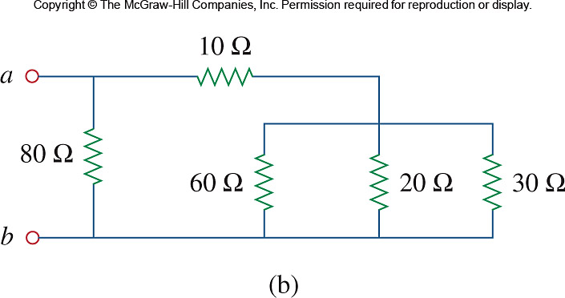

Figure 2.107
For Prob. 2.43

